Chat and share files in Teams
Start a new conversation...
...with the whole team
- Click Teams , then pick a team and a channel.
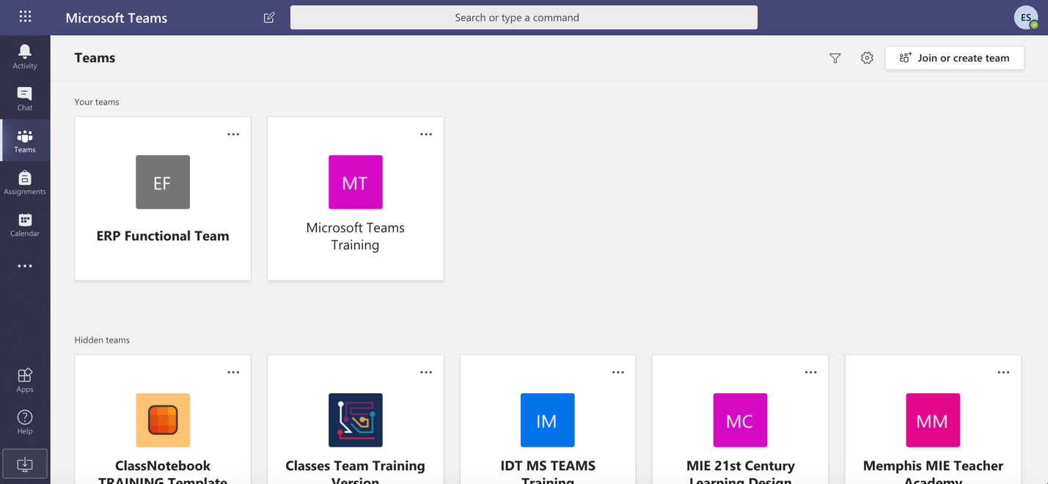
- In the box where you type your message, say what's on your mind and click Send .
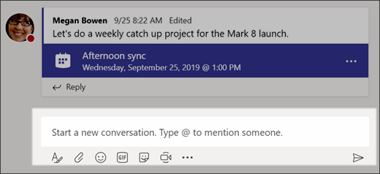
Send

...with a person or group
- At the top of the app, click New chat .
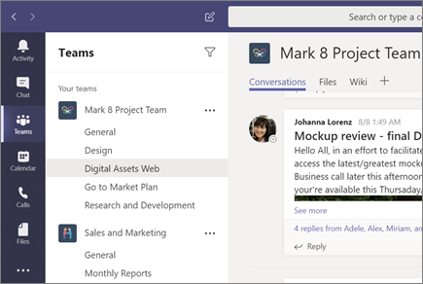
- In the To field, type the name of the person or people you want to chat with.
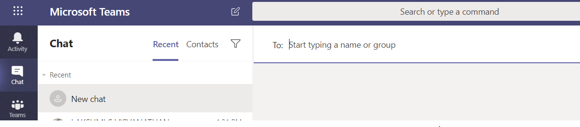
- In the box where you type your message, say what's on your mind and click Send .
Send

Reply to a conversation
Channel conversations are organized by date and then threaded. The replies in threads are organized under the initial post so it's easier to follow multiple conversations.
- Find the conversation thread you want to reply to.
- Click Reply, add your message, and click Send .
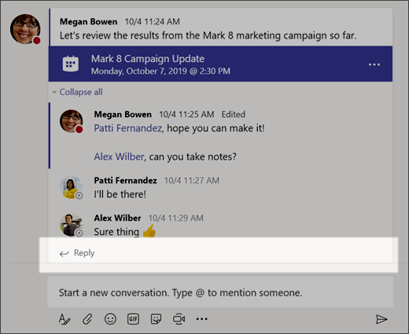
Send

Share a file
Sometimes words aren't enough, and you need to post a file to a channel conversation.
Tip: Teams works particularly well with Microsoft Office documents.
- In your channel conversation, click Attach under the box where you type your message.
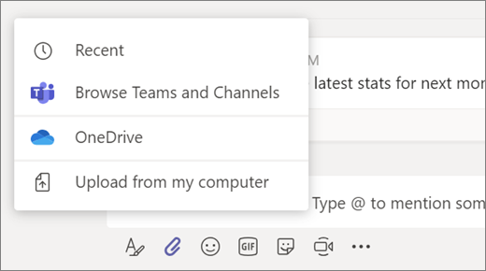
- Select from these options:
  - Recent
  - Browse Teams and Channels
  - OneDrive
  - Upload from my computer

- Select a file > Share a link or Upload.
If you're uploading a file from your computer, select a file, click Open, and then Send .
You can always see all the files you post to a channel by going to the Files tab.

